CLASS TEST
1/09/2026
Ch- 5 Our Vibrant Country FM -10
Answer The following questions. ( Q1 and 2 contains 3 marks Q3 contains 2 marks and Q4&5 contains 1 marks each )
Q1 . Observe the ₹50 currency note carefully and answer the following questions:
a.Name the historical monument is depicted on the reverse (back) side of the banknote?
b.Which year of printing is visibly inscribed vertically on the left side of the note's reverse side?
C. Name any 2 symbol visible on this note .

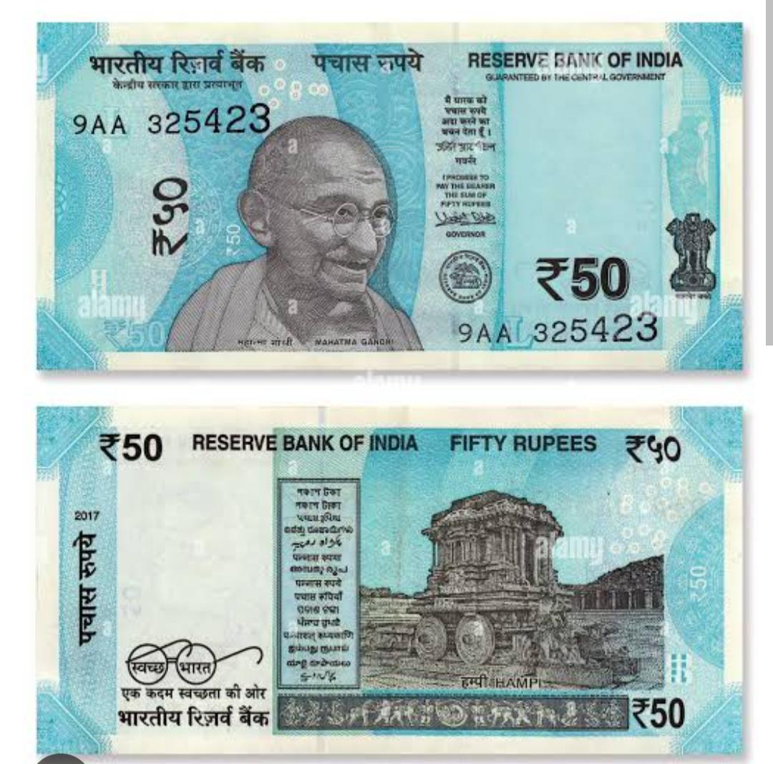
Q2 . Draw National Flag of India also write what each of the colours present on it symbolises.

Q3 . Name any one historical Monument in India. Also write One importance of preserving historical monuments.
Q4 . Assertion (A): India is a secular country.
Reason (R): The Indian Constitution gives equal respect and freedom to people of all religions.
a.Both A and R are true, and R is the correct explanation of A.
b.Both A and R are true, but R is not the correct explanation of A.
c..A is true, but R is false.
d.A is false, but R is true.
Q5 . Assertion (A): The National Emblem of India is a symbol of the sovereignty and unity of India.
Reason (R): The National Emblem is adopted from the Lion Capital of Ashoka at Sarnath.

